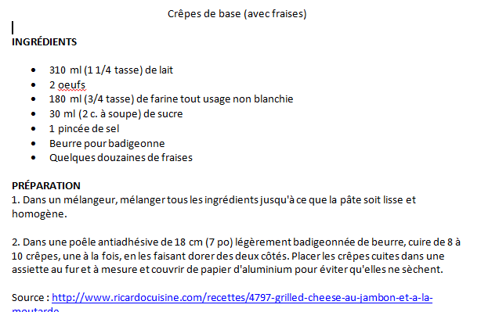
The report must include all the sections below.
Step 1: Recipe selection
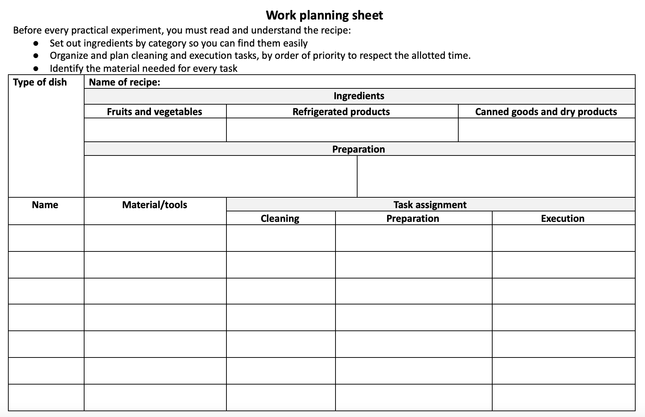
- Recipe presented (list of ingredients, steps to follow and reference site). Clearly identify any modifications or adjustments to the original recipe.
Step 2: Planning
- List of required material.
- List of ingredients with quantity (in table).
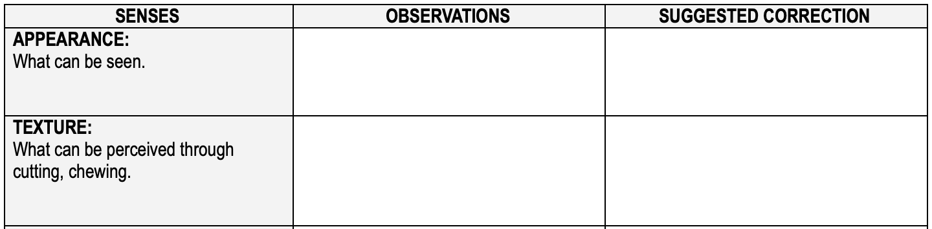
- Planning brigade tasks (steps in order) with an approximation of execution time (in table).
Step 3: Analysis sheet
- Meal evaluation with justification grid (tasting sheet).
Step 4: Work self-evaluation sheet
- Brigade strengths and areas for improvement
- Personal strengths and areas for improvement
Step 5: Nutritional value
- Explanatory text on healthy food and its benefits [3] including footnotes
There was a whole apple in our recipe. Apples have many health benefits. For example, in a study conducted by Experimental Biology, people who eat apples regularly reduce their chance of developing a metabolic syndrome such as diabetes by 27% thanks to the ellagic acids contained in the apple peel. Moreover, apples are also beneficial to diabetics since, despite their sugar content, they do not cause a glucose spike in the bloodstream.
Eating apples (ideally 2 or more per week) has a favourable effect on the respiratory function as well as on the incidence of asthma and respiratory tract diseases. The polyphenols and flavonoids contained in apples could increase the antioxidant capacity of the body and thus reduce the inflammatory response in asthmatics. Another element, quercetin, could have an anti-cancer effect and increase the body’s defenses against infection by preventing oxygen molecules from attacking the body’s cells.
Furthermore, an apple is rich in soluble and insoluble fibres. Apples are particularly rich in pectin, a soluble fibre that fixes large quantities of water in the intestines and promotes fat metabolism. On the other hand, insoluble fibres act as cleansing agents in the intestines. The soluble and insoluble fibres in apples work together to remove many toxic agents (including mercury and lead) from the body and play a protective role against certain cancers.

Comment ça marche, web page http://sante-medecine.commentcamarche.net/faq/40-pommes-bienfaits-pour-la-sante, consulted on September 6, 2014
Ma santé naturelle, la pomme, web page, http://www.masantenaturelle.com/chroniques/sante/pommes.php consulted on September 7, 2014
Passeport santé, la pomme, web page, http://www.passeportsante.net/fr/Nutrition/EncyclopedieAliments/Fiche.aspx?doc=pomme_nu , consulted on September 7, 2014
Plaisir santé, web page, http://www.plaisirssante.ca/mon-assiette/nutrition/5-super-vertus-des-pommes, consulted on September 8, 2014
Ma santé naturelle, la pomme, web page, http://www.masantenaturelle.com/chroniques/sante/pommes.php consulted on September 7, 2014

