Document 2 _Analysis of the selected company’s production

In this table, you must present all the cheeses your company produces.

 | Name of cheese | Image | Description (characteristics) | Price (kg)

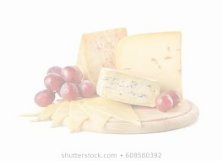
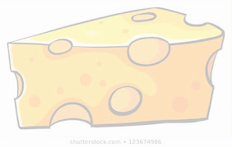

Document 2 _Analysis of competitor products company 1

In the previous section, you described the products your company offers. (Document 3)
You must now find at least five (5) different products offered by other cheese producers. Be sure to select cheeses with different characteristics from what your company offers.

 | Name of cheese | Image | Description (characteristics) | Price (kg)

Document 2 _Analysis of competitor products company 2

In the previous section, you described the products your company offers. (Document 3)
You must now find at least five (5) different products offered by other cheese producers. Be sure to select cheeses with different characteristics from what your company offers.

 | Name of cheese | Image | Description (characteristics) | Price (kg)

