Scenario — Composition of raw matter

Sensory analysis of milk by comparing whole milk, skim milk, yogurt and cheese. Two suggested scenarios: Section A Goat milk, Section B Cow milk

Section A: Goat milk
Complete the following table using the elements provided

Criteria | 1% Milk | 3.25% Milk | Yogurt | Cheese
Sight:
Appearance, colour

Smell:
floral, vegetal, milky, woodsy, smoky, chemical….
Taste:
sweet, salty, sour, bitter, umami
Flavour:
fruit, flower, vegetal, vanilla…
Texture:
soft, lumpy, crunchy, airy, fatty…
Touch:
silky, greasy, crumbly

Using the nutritional values table, compare the composition of the 4 dairy products regarding carbohydrates, protein and lipids. Suggest a hypothesis to explain the differences.

Milk 1% | Milk 3.25% Riviera
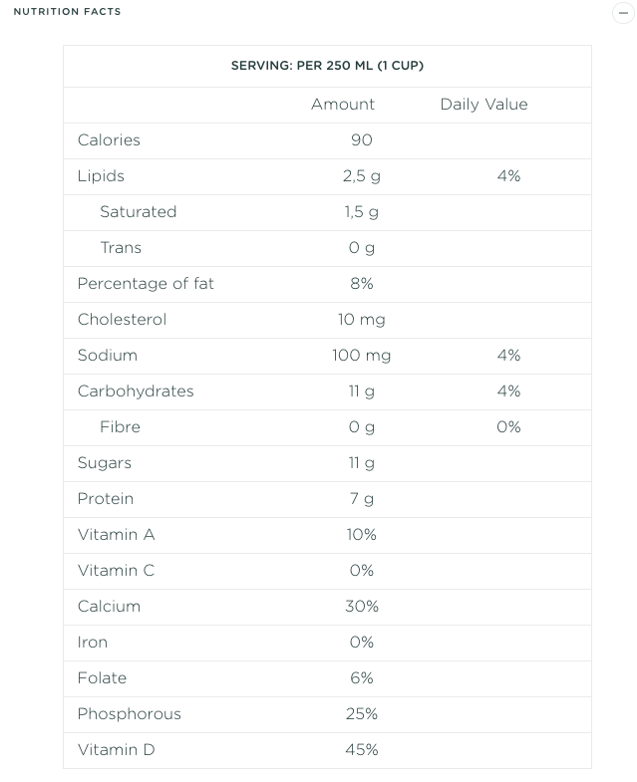  INGREDIENTS  Partly skimmed pasteurized goat milk  Vitamin A palmitate  Vitamin D3  Folic acid  Source: https://riviera1920.com/en/product/goat-milk-1-m-f/ | 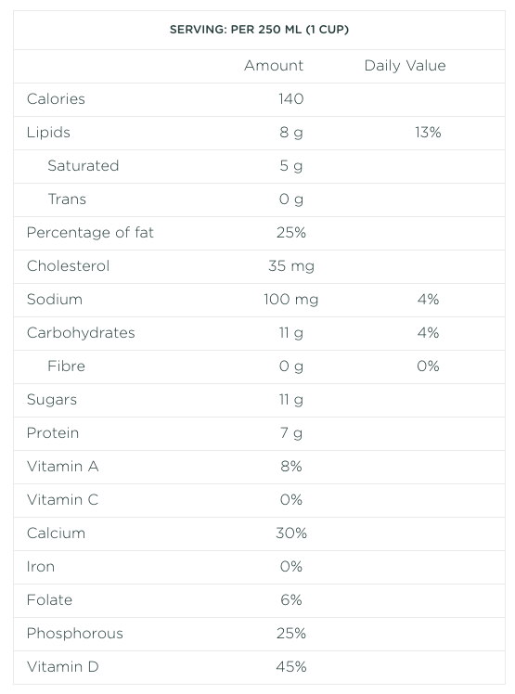  INGREDIENTS  Pasteurized goat milk  Vitamin D3  Folic acid  M.F.: 3.25%  Size: 1 L  Source: https://riviera1920.com/en/product/goat-milk-3-25-m-f/

Yogourt | Cheese Curds
Plain Yogourt  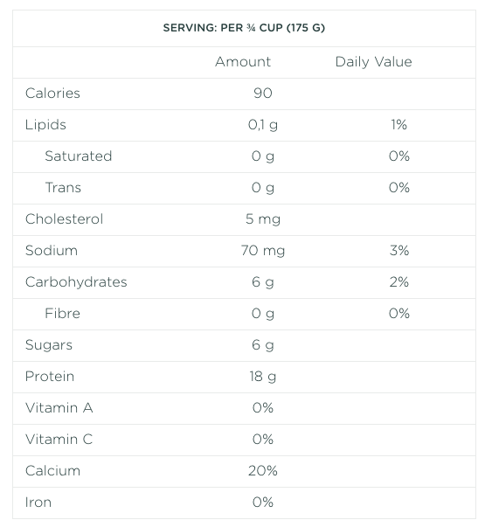  INGREDIENTS  Ultrafiltered skim goat milk  Goat cream  Bacterial cultures  Vitamin D3  M.F.: 4.9%  Size: 500 g  Source: https://riviera1920.com/en/product/plain-goat-yogourt-500-g/?cat=goat-milk-products | 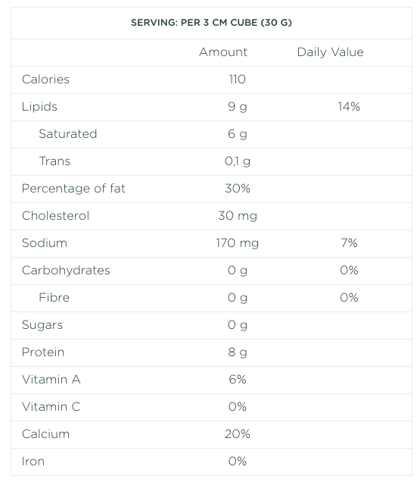  INGREDIENTS  Pasteurized goat milk  Salt  Calcium chloride  Microbial enzyme  Bacterial culture  Source: https://riviera1920.com/en/product/goat-cheddar/

Section B: Cow milk
Complete the following table using the elements provided
Criteria | Skim Milk | Whole Milk | Yogourt | Cheese
Sight:
Appearance, colour

Smell:
floral, vegetal, milky, woodsy, smoky, chemical….
Taste:
sweet, salty, sour, bitter, umami
Flavour:
fruit, flower, vegetal, vanilla…
Texture:
soft, lumpy, crunchy, airy, fatty…
Touch:
silky, greasy, crumbly

Using the nutritional values table, compare the composition of the 4 dairy products regarding carbohydrates, protein and lipids. Suggest a hypothesis to explain the differences.
Skim Milk | Whole Milk
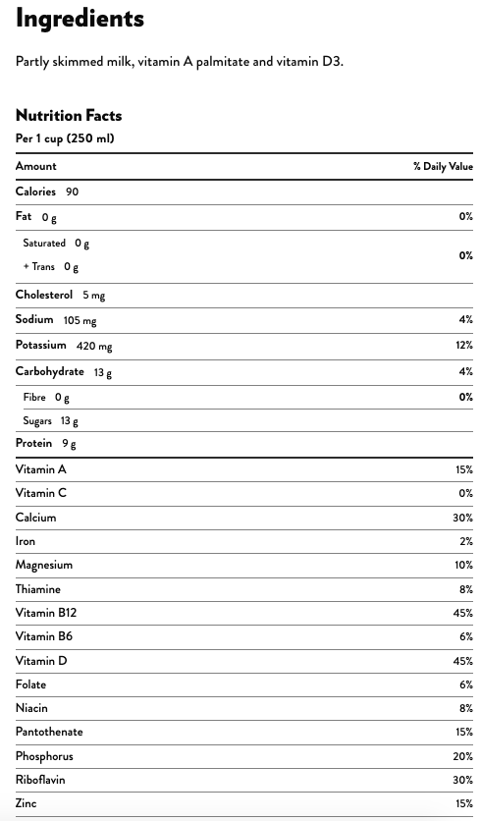  Source: https://www.natrel.ca/en/products/fine-filtered-milks/fine-filtered-skim-milk | 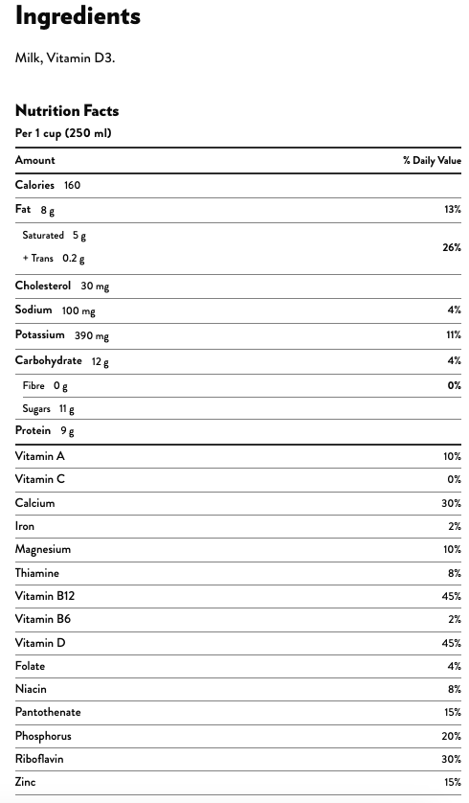  Source: https://www.natrel.ca/en/products/fine-filtered-milks/fine-filtered-325-milk

Yogurt | Cheese Curds
Plain Greek Yogurt  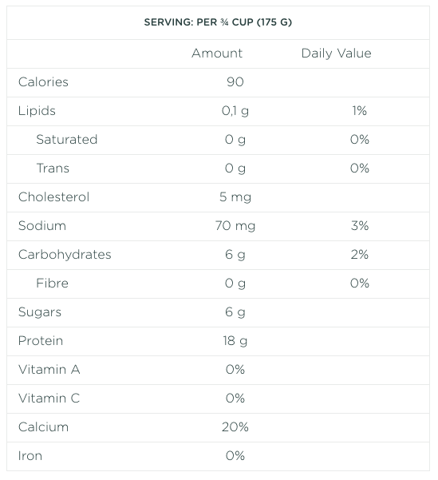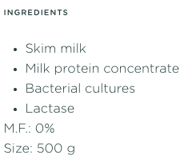  Source: https://riviera1920.com/en/product/plain-greek-yogourt-500g/ | 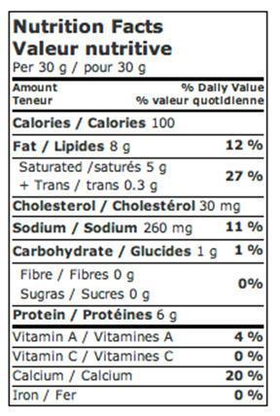  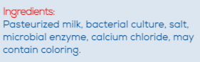  Source :https://fromagestalbert.com/our-products/our-cheeses/?lang=en

Looking at the components of the cheese, what type of milk should you use to make cheese? Explain your answer.

