SWOT analysis of your two best ideas for new cheese products

Internal analysis  Strengths and weaknesses of aspects of your business you can control  - Advantages over your competition  - Management team (owners)  - Values and reputation  - Resources: financial, intellectual, human…  - Experience  - Equipment  - Location  - Brand  - Customer service  - Delivery times  - Warranty  - Company size  - 4 Ps (price, place, promotion, product)  - Etc. | External analysis  Opportunities and threats for aspects of your business you can’t control  - Government decisions  - Population (health, tastes, size, financial situation, location…)  - Taxes  - Laws  - Competition  - National and international economy  - International trade  - Climate  - Culture  - Etc.

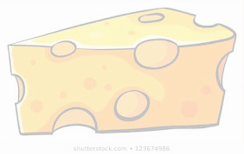
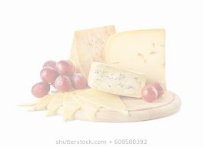

First idea

- Short description of the idea (2-3 sentences)

- I like this idea because…

- This is a great idea for my company because…

- Conduct a SWOT analysis of the first idea.

Strengths | Weaknesses
Opportunities | Threats

